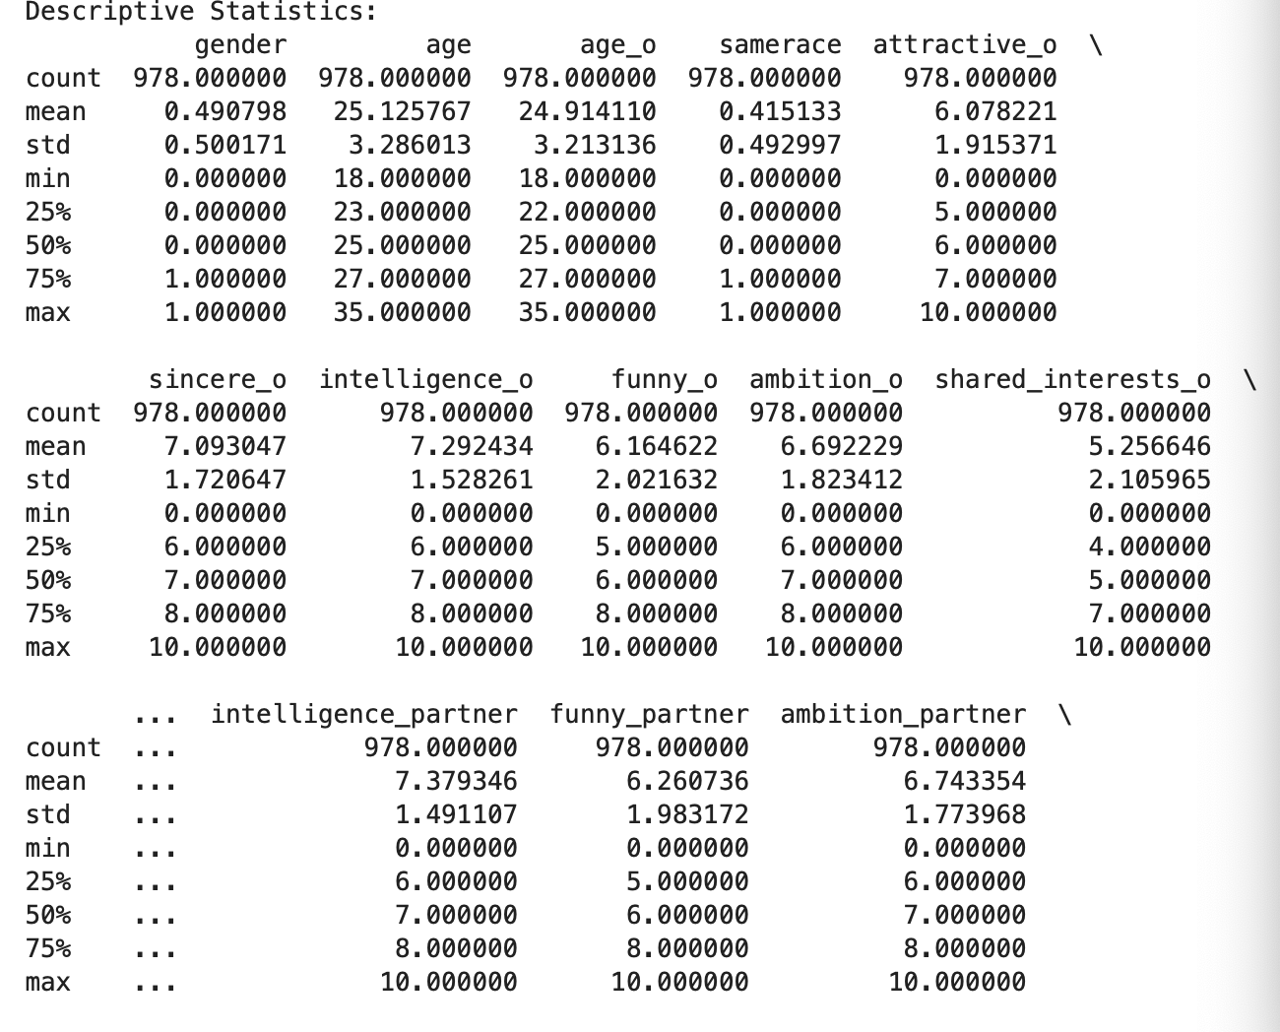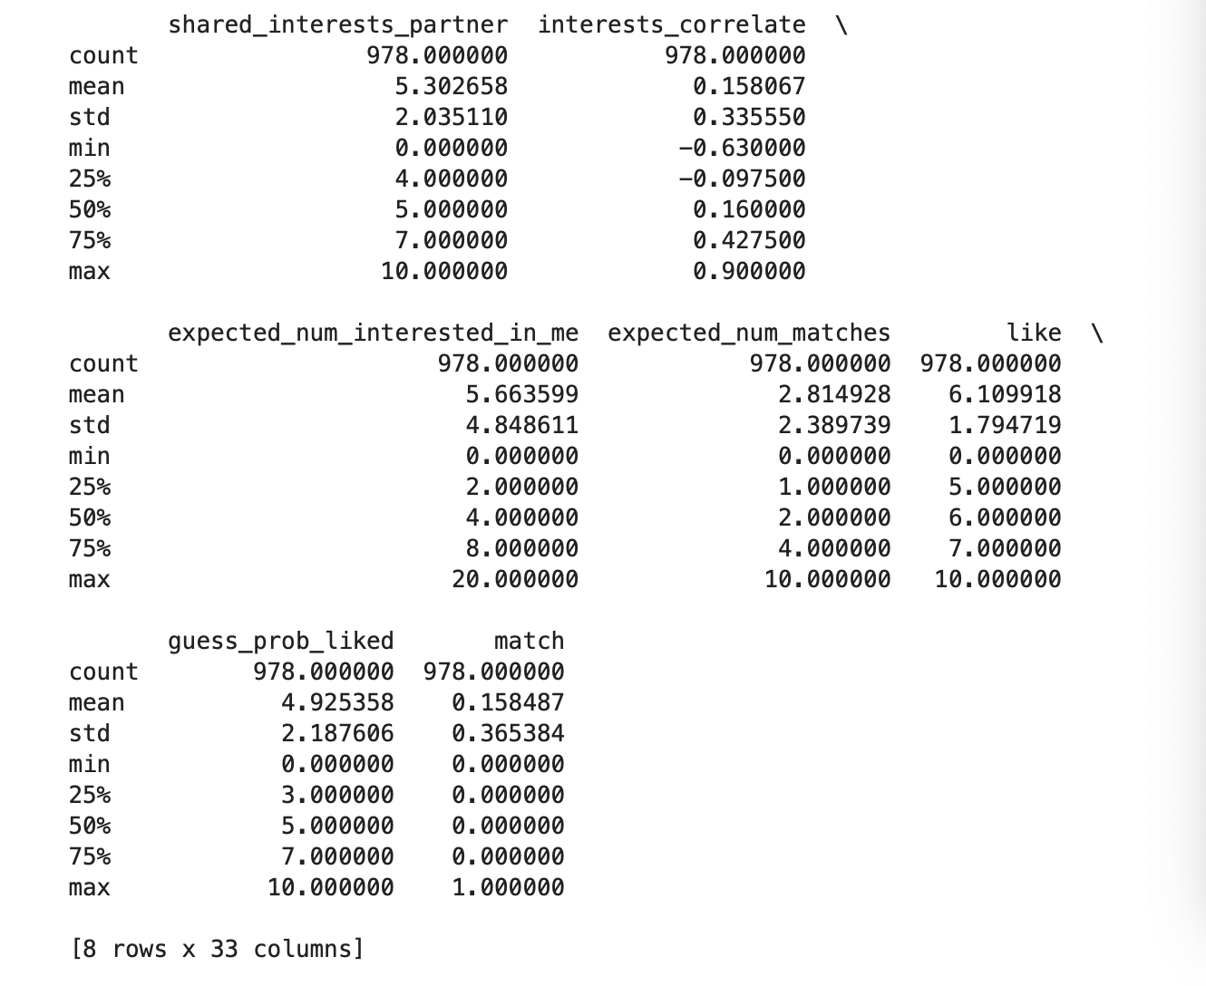
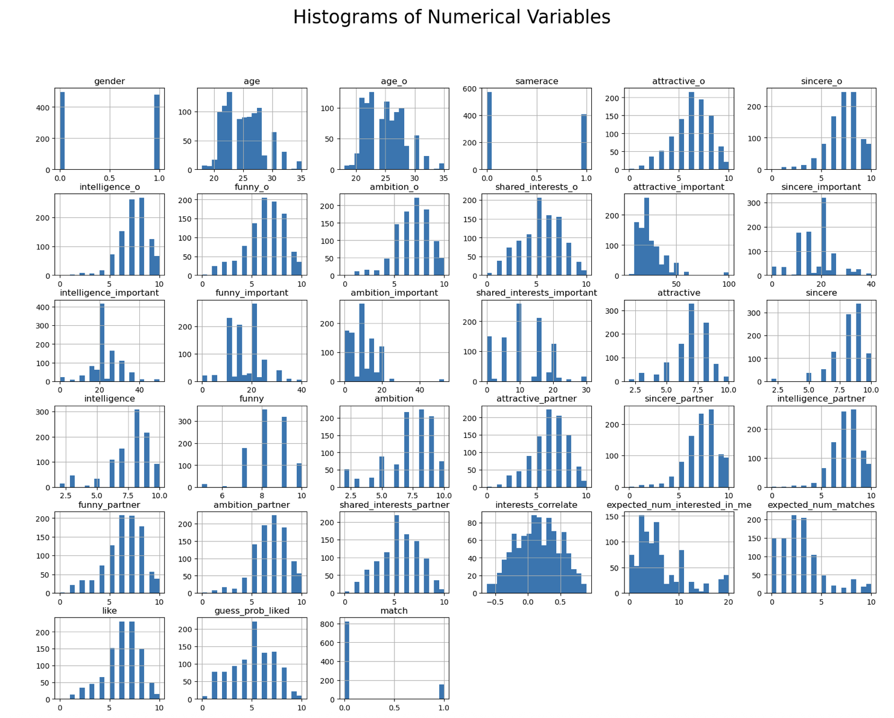
The dataset contains 978 observations, and the gender distribution is nearly balanced (mean of gender ≈ 0.49). The average age of participants (age) and their partners (age_o) is approximately 25 years. The interquartile range indicates that most ages fall between 23 and 27 years, which is also confirmed by the histograms. Variables such as attractive_o, sincere_o, and intelligence_o have mean values between 6 and 7. The interquartile range is roughly 5–8, suggesting that ratings are generally moderate to high. Histograms show these distributions are concentrated in the mid-range. Self-assessment and partner ratings (e.g., intelligence_partner, funny_partner) also average between 6 and 7, indicating overall positive evaluations. The match variable has a mean of only 0.158, meaning the match rate is about 15.8%, which suggests that successful matches are relatively rare. The mean of interests_correlate is approximately 0.16, indicating low correlation in interests between participants. The expected number of matches averages 2.8, which is much higher than the actual match rate.

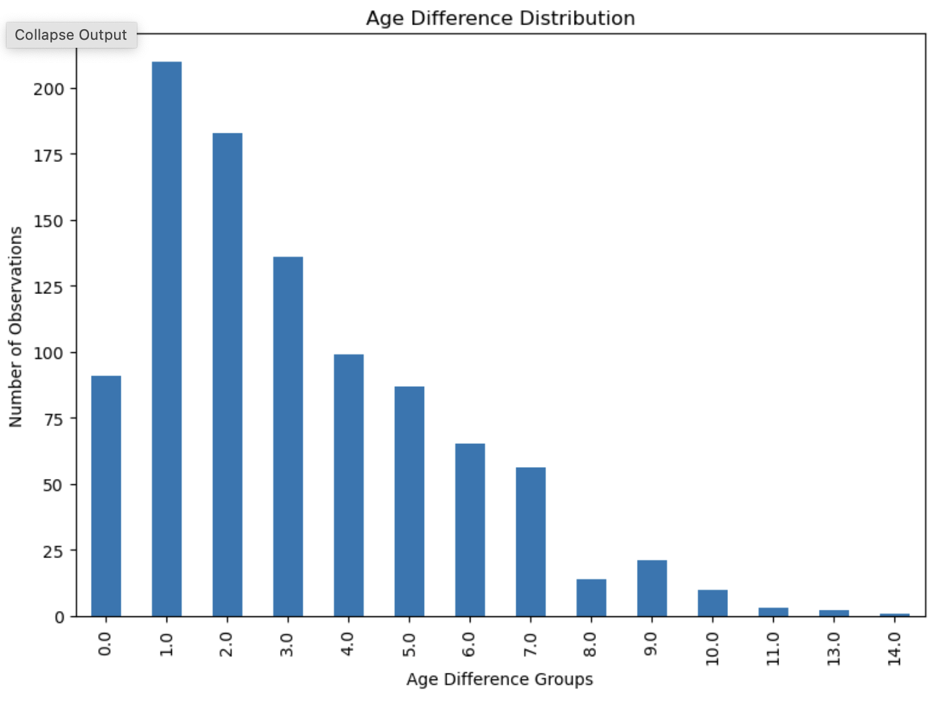
The bar chart shows that most age differences fall within 0–5 years, with 1-year difference being the most frequent, exceeding 200 observations. As the age gap increases, the frequency decreases significantly, and differences greater than 10 years are rare. This indicates that participants generally have small age gaps.
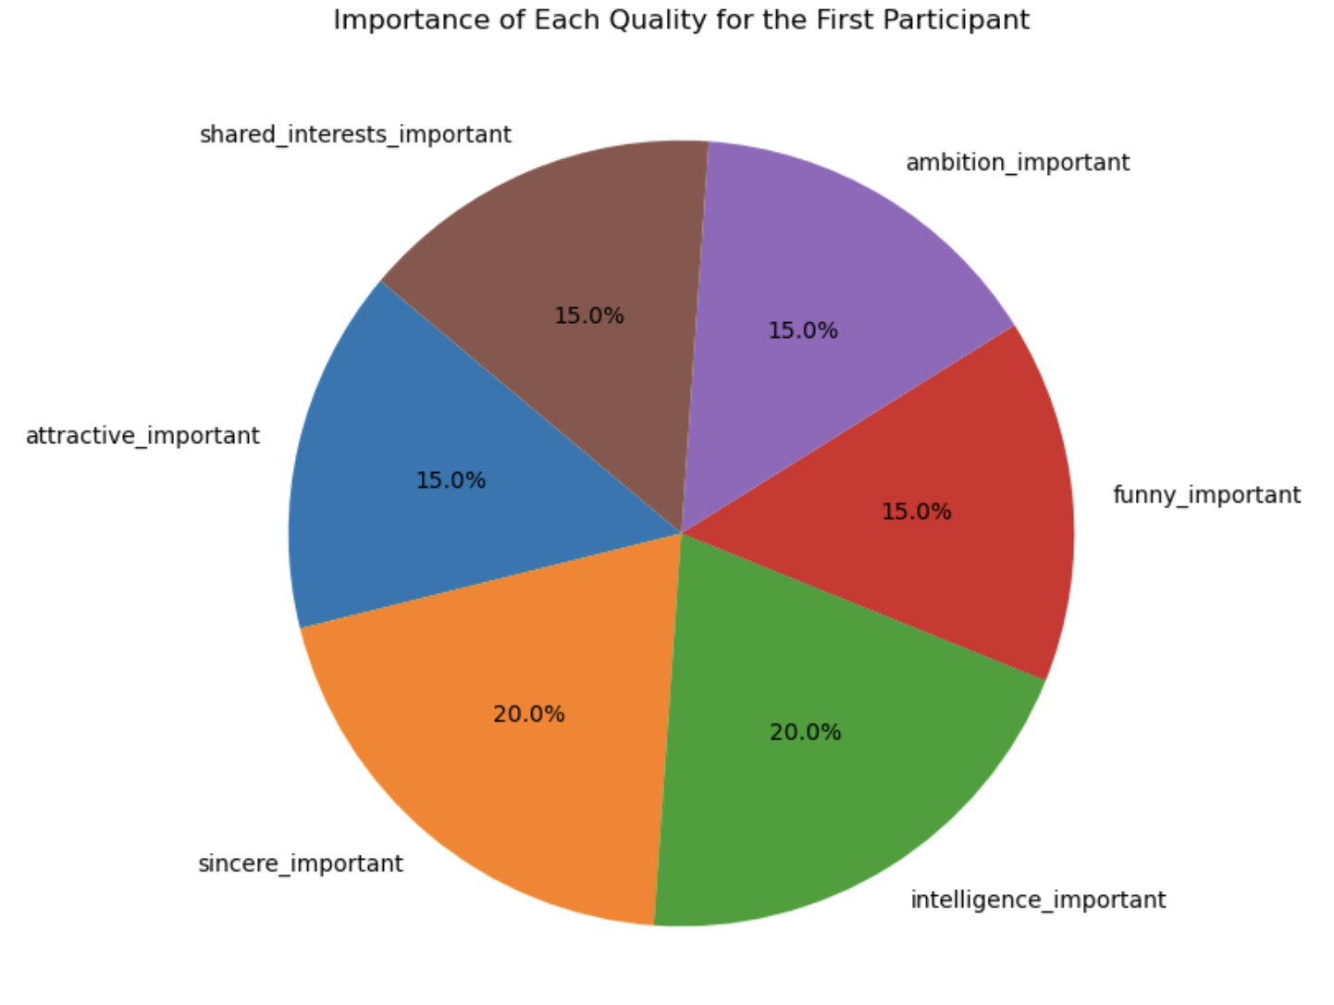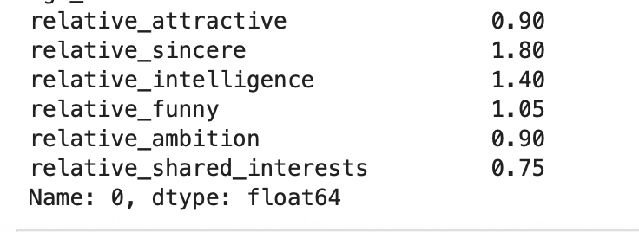
The pie chart shows that the first participant values “sincerity” and “intelligence” the most (20% each), while “attractiveness,” “funny,” “ambition,” and “shared interests” each account for 15%.The relative scores for the first participant indicate that sincerity (1.80) and intelligence (1.40) have the greatest influence, while shared interests (0.75) and ambition (0.90) have less impact. This suggests that sincerity and intelligence are key factors for this participant in forming a match.
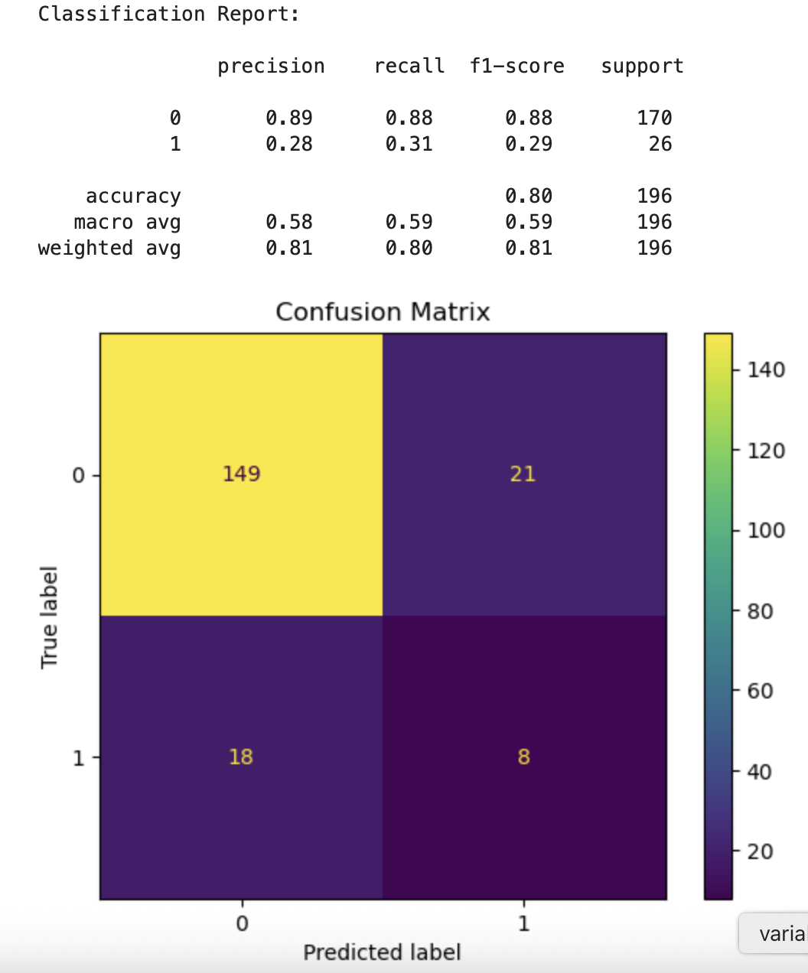
The classification report shows an overall accuracy of 80%, but due to class imbalance, the model performs poorly on predicting the “match” class (1): precision is only 0.28, recall 0.31, and F1-score 0.29
The confusion matrix indicates that the model predicts the “no match” class (0) well (149 correct predictions), but only 8 correct predictions for the “match” class, with a high misclassification rate. This suggests the model is biased toward the majority class and could be improved by using more advanced models or applying techniques to handle class imbalance.

